Project Design Phase-II
Technology Stack (Architecture & Stack)

Date | 6 February 2026
Team ID | LTVIP2026TMIDS61992
Project Name | visualization tool for electric vehicle charge and range analysis
Maximum Marks | 4 Marks

Technical Architecture:
The Deliverable shall include the architectural diagram
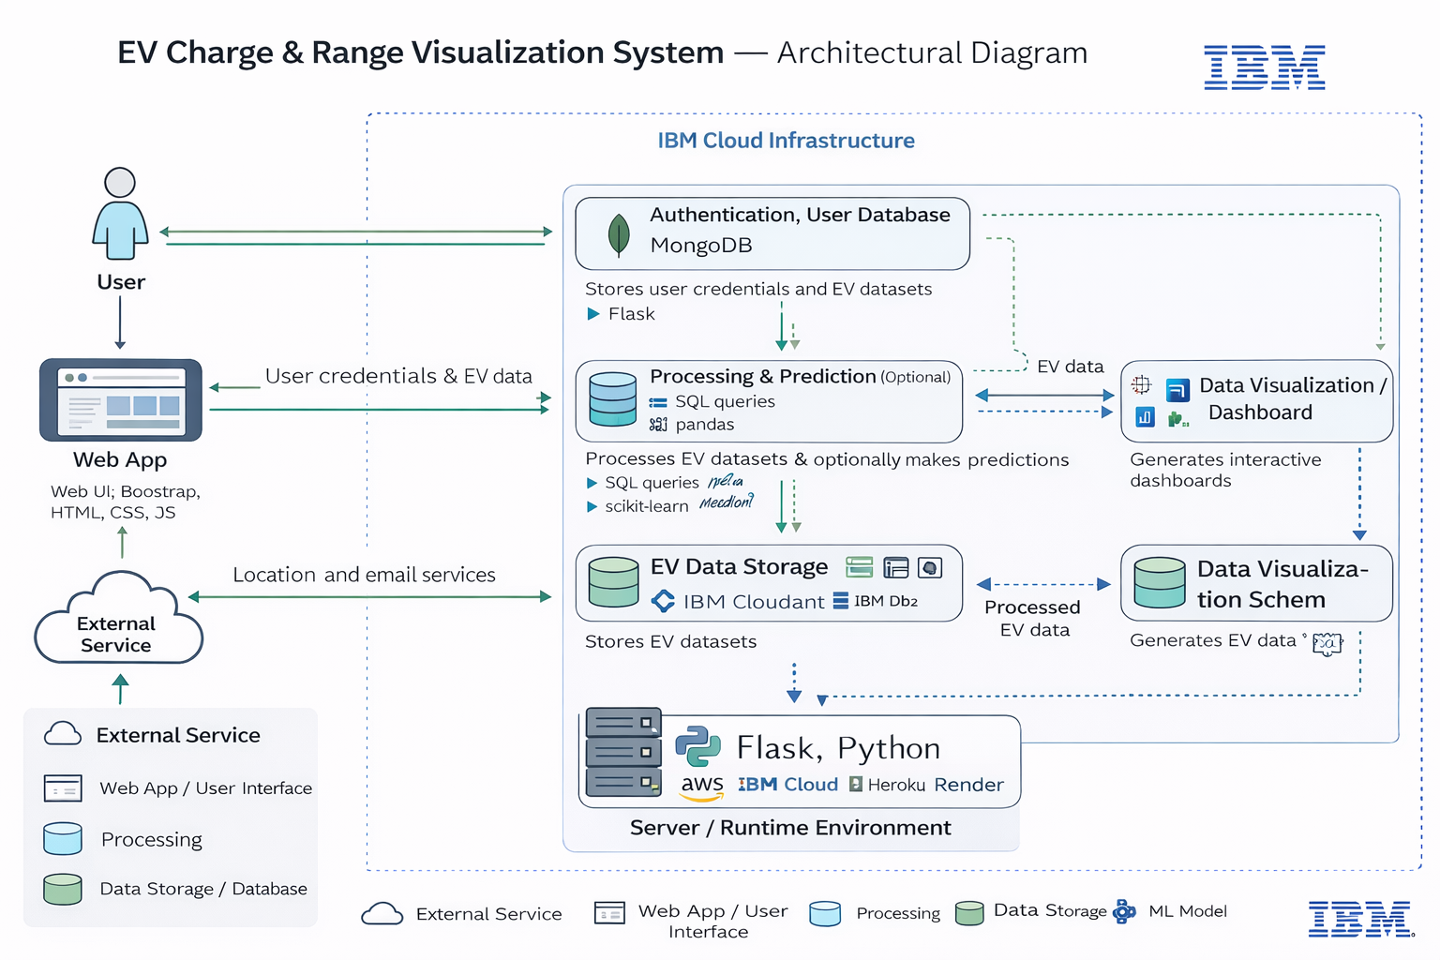

Table-1 : Components & Technologies:

S.No | Component | Description | Technology
 | User Interface | Web interface where users register, log in, and view EV charge and range analytics dashboards | HTML, CSS, JavaScript, Bootstrap
 | Application Logic-1 | Handles user authentication, registration, and session management | Python (Flask)
 | Application Logic-2 | Data processing logic for EV charging and range analysis | Python (Pandas, NumPy)
 | Application Logic-3 | Visualization logic for interactive dashboards and charts | Tableau / Plotly / Matplotlib
 | Database | Stores user accounts, EV datasets, and session data | SQLite / MySQL
 | Cloud Database | Optional cloud storage for datasets and user data | Firebase / AWS RDS (optional)
 | File Storage | Stores EV datasets, uploaded files, and static assets | Local File System / Cloud Storage
 | External API-1 | Map or location data for EV charging station references (optional) | Google Maps API (optional)
 | External API-2 | Email service for account verification | SMTP / Gmail API
 | Machine Learning Model | Predicts EV range or charging performance based on dataset (optional feature) | Scikit-learn
 | Infrastructure (Server / Cloud) | Deployment environment for the web application | Local Server / AWS / Heroku / Render

Table-2: Application Characteristics:

S.No | Characteristics | Description | Technology
 | Open-Source Frameworks | Frameworks used to build the application | Flask, Bootstrap, Pandas
 | Security Implementations | Password hashing, secure login, and session control | SHA-256 / Flask Login / HTTPS
 | Scalable Architecture | Modular structure separating UI, backend logic, and data processing | 3-tier architecture using Flask
 | Availability | System hosted on reliable server or cloud platform | Localhost / Cloud hosting (AWS/Render)
 | Performance | Optimized data processing and fast dashboard loading | Pandas optimization, caching techniques

